**Ghulam Hassan Bhat**

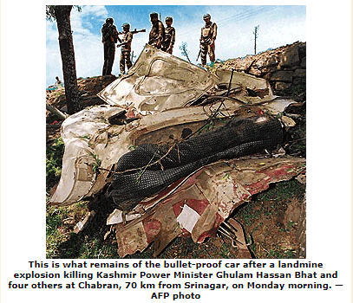

**About :** Jammu and Kashmir Minister of State for Power Ghulam Hassan Bhat was killed along with four others when militants triggered a landmine blowing up the vehicle on the Dooru-Qazigund road in Anantnag district this morning.

**Murdered on:  May16,2000**

**Attack Details:** Eight militants, including three top commanders of different outfits, and a special police officer (SPO) were among 10 persons killed in Jammu and Kashmir, where ultras set off two IEDS while the security forces rescued a boy from the clutches of ultras since last night, a police

**Reason To Him Targeate:** Minister of State for Power.

**Occupation:** Bhat was a popular and respected political leader.

**URL:** <https://www.tribuneindia.com/2000/20000516/main1.htm>

|  |
| --- |
|  |